**Drought Index Portal (DrIP)**

*A tool to display, compare, and extract time series for various indicators of drought in the Contiguous United States.*

Drought can represent various forms of water shortage and is often categorized according to the type of Earth or social system it affects (hydrological, meteorological, agricultural, etc.). In turn, there are many different indices designed to reflect different forms of drought. There is no singular index that can be used for all applications and, even within one application, indices will vary across space in terms of utility.

It has been suggested by the research community to apply a multi-index approach to complex water management problems, or at least to explore multiple indices before basing decisions on any singular index. Such an exploration can be tedious without extensive efforts to acquire, calculate, and manipulate index data. There are services that automate the process, provide data for a suite of indices, and allow for comparisons such as this (see the [Drought Risk Atlas](https://droughtatlas.unl.edu/) of the [NDMC](https://drought.unl.edu/), the [US Water Watcher](https://climatetoolbox.org/tool/US-Water-Watcher), or the [WestWide Drought Tracker](https://wrcc.dri.edu/wwdt/current.php?folder=spi3&region=ww)). However, while these are invaluable resources, they do not provide the basic ability to quickly compare both spatial and temporal patterns of drought according to different indices. Therefore, this online tool was created to provide a singular portal in which to perform quick visual comparisons across time and space between a collection of drought index products.

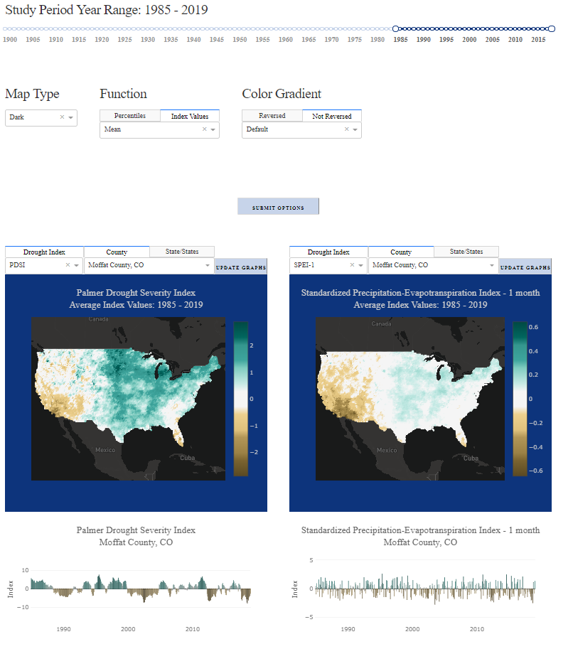

**Figure 1.** A comparison of the Palmer Drought Severity Index and the 1-month Standardized Precipitation-Evapotranspiration Index as average values across the Contiguous United States and as a time-series of monthly values in Moffat County, Colorado.

# What

The application currently displays two side-by-side panels of drought indices over the Contiguous United States. For now, five drought indices are available: The Palmer Drought Severity Index (PDSI), the Standardized Precipitation Index (SPI), the Standardized Precipitation-Evapotranspiration Index (SPEI), the Evaporative Demand Drought Index (EDDI), and the Landscape Evaporative Response Index (LERI). The SPI, SPEI, and EDDI are multi-scalar indices for which 1-, 2-, 3-, and 6-month time periods are available. LERI is also a multi-scalar index, though only the 1- and 3-month time periods are available. In addition to the PDSI, the Self-Calibrating PDSI and the related Palmer Z Index are also available, bringing the total number of available indices to seventeen.

For each panel, you may select any index from above to display a map of values within a specified study area and time period. Values may be presented as mean, min, or maximum values. Values may also be expressed as percentiles or in the original index value space. When using the original index values, information may also be presented as the percent of the selected area in various drought categories, or as a map of Pearson’s correlation coefficients for each individual location with a given areal selection. For most indices, excepting EDDI and LERI, the study period can include any number of months since 1900. EDDI is only available since 1980, and LERI since 2000, because these use more sophisticated methods of calculating evapotranspiration that require data which was not available at earlier times.

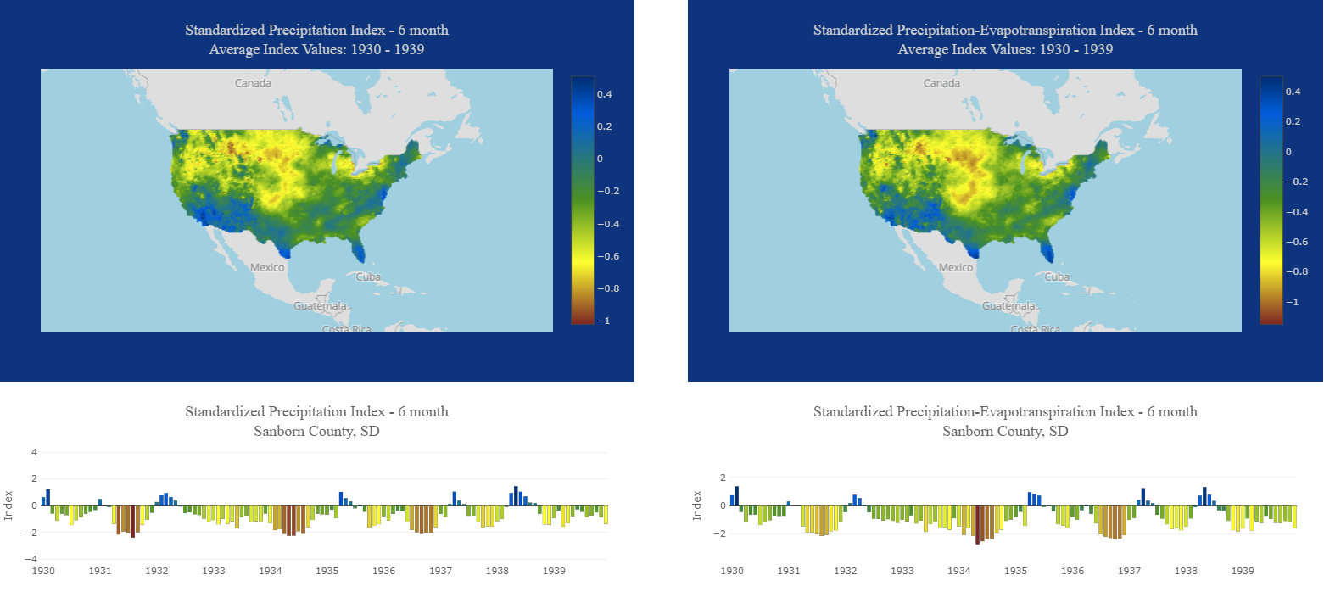

**Figure 2.** The spatial extent of drought in the 1930’s, as exhibited by average SPEI and SPI values at the 6-month time-scale, with an example time series in Sanborn County, South Dakota.

## Colors

We feel that it is important to provide as many perspectives of drought as possible, and also that the color schemes used to display this information affects the perception of the phenomenon. Therefore, eighteen different color scales are available along with the ability to reverse scales for cases where defaults are counterintuitive. These defaults are set to a red, white, and blue scale for percentiles and a brown, white, green scale for original index values.The “RdWhBu (Extreme Scale)” is based on the National Oceanic and Atmospheric Administration Physical Science Division’s percentile color scale used for EDDI and LERI, and highlights particularly wet and dry periods. An example of this scale is displayed in **Figure 3**. All color scales are kept relative to the chosen time period because they quickly homogenize over time as values approach the mean (particularly for percentiles).

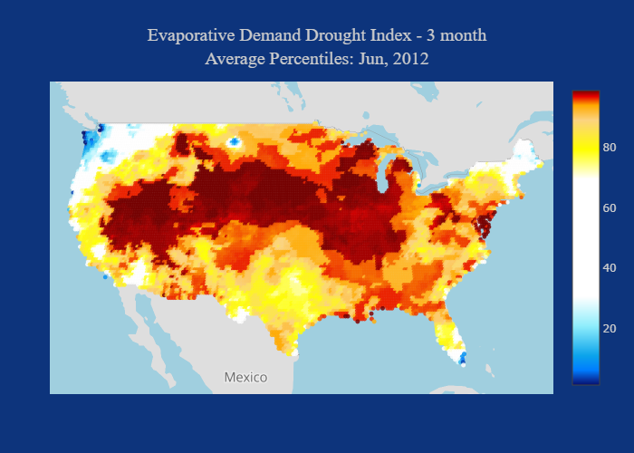

**Figure 3.** The “RdWhBu (Extreme Scale)” color scheme allows for the identification of categorical drought events. It also incorporates a slight gradient within each category to allow for further differentiation of severity. This option works best for a single month because colors quickly converge on white as values are averaged over longer time periods.

Data was acquired from the WestWide Drought Tracker of the Desert Research Institute and [NOAA's Physical Sciences Division](https://www.esrl.noaa.gov/psd/).

# How

To change the default values of maps and time series graphs click the “DISPLAY OPTIONS” button underneath the application title. These options apply to each map. The study period can be adjusted to include any number of years from 1900 to present. To select the beginning and end month of the study period, select these values in the appropriate drop-down menus in the “Beginning” and “Ending Month” sections. To filter the time series by specific months, click the appropriate boxes in the “Included Months” section. Change the base map by selecting a value under the “Map Type” section. Change the function applied to each index using the “Function” section. Change the color scale by selecting a value in the “Color Gradient” section. Reverse this scale by selecting the “Reversed” or “Not Reversed” tab. When you are finished setting each parameter, click “SUBMIT OPTIONS” to render the maps and time series graphs.

To change the default values of each map element individually, use the drop-down options above each element. The “Drought Index” drop-down displays the acronyms associated with each available index. A list of the full index names can be found by clicking the “DESCRIPTION” button below the application title. Each point in the resulting map represents the a 0.25 by 0.25 decimal degree grid cell. Hovering over these points shows the index value and county of each location. Hovering over the map and scrolling allows you to zoom and search the base map for a particular location. Clicking and dragging the mouse allows you to pan the map. Holding control, clicking, and dragging the mouse allows you to change the viewing aspect.

Clicking on a point renders a time series of monthly index values for that individual grid cell as a bar graph below each map. Because grid cells are represented as points, it is possible to zoom in beyond them, view geographic labels, and click the closest point. Selecting a county from the “County” drop-down will select multiple points if the county contains multiple grid cells. Because counties often render only a single or a few points, this selection does not alter the map. It is also possible to choose multiple grid cells with the box or lasso selection tool. Selecting multiple points will render a time series of monthly values averaged within that selection, and this selection will be highlighted in the map. By clicking and dragging the box selection tool directly up or down (or left or right) you can select a range of latitudes (or longitudes) (**Fig. 4**). The “State/States” tab allows the user to filter values by a collection of states. Drop-down values may be chosen by either selecting a value from the drop-down menu or by typing into the value field and pushing enter. Because the state option is a multi-selection, the graphing elements are prevented from updating until each desired state is entered and the “UPDATE” button is clicked. Users may also use a shapefile to filter values. To do so, click on the “Shapefile” tab to open the upload portal. Here, provide the shapefile elements (as a zipped folder or a multi-selection) by clicking on “select files” and searching the directory or by dragging and dropping. This will filter values in the same way the state filters do and will set the time series title to the name of the shapefile (or zipped folder). Once the map is filtered by either states or a shapefile, it may be restored to the full study area by clicking the “RESET” button.

**Figure 4.** The Drought Comparison Portal allows for a high degree of flexibility when selecting areas over which to aggregate various metrics of drought. Displayed here are averages from the selection of a range of longitudes and latitudes of PDSI percentile values from 1985 to 2019.

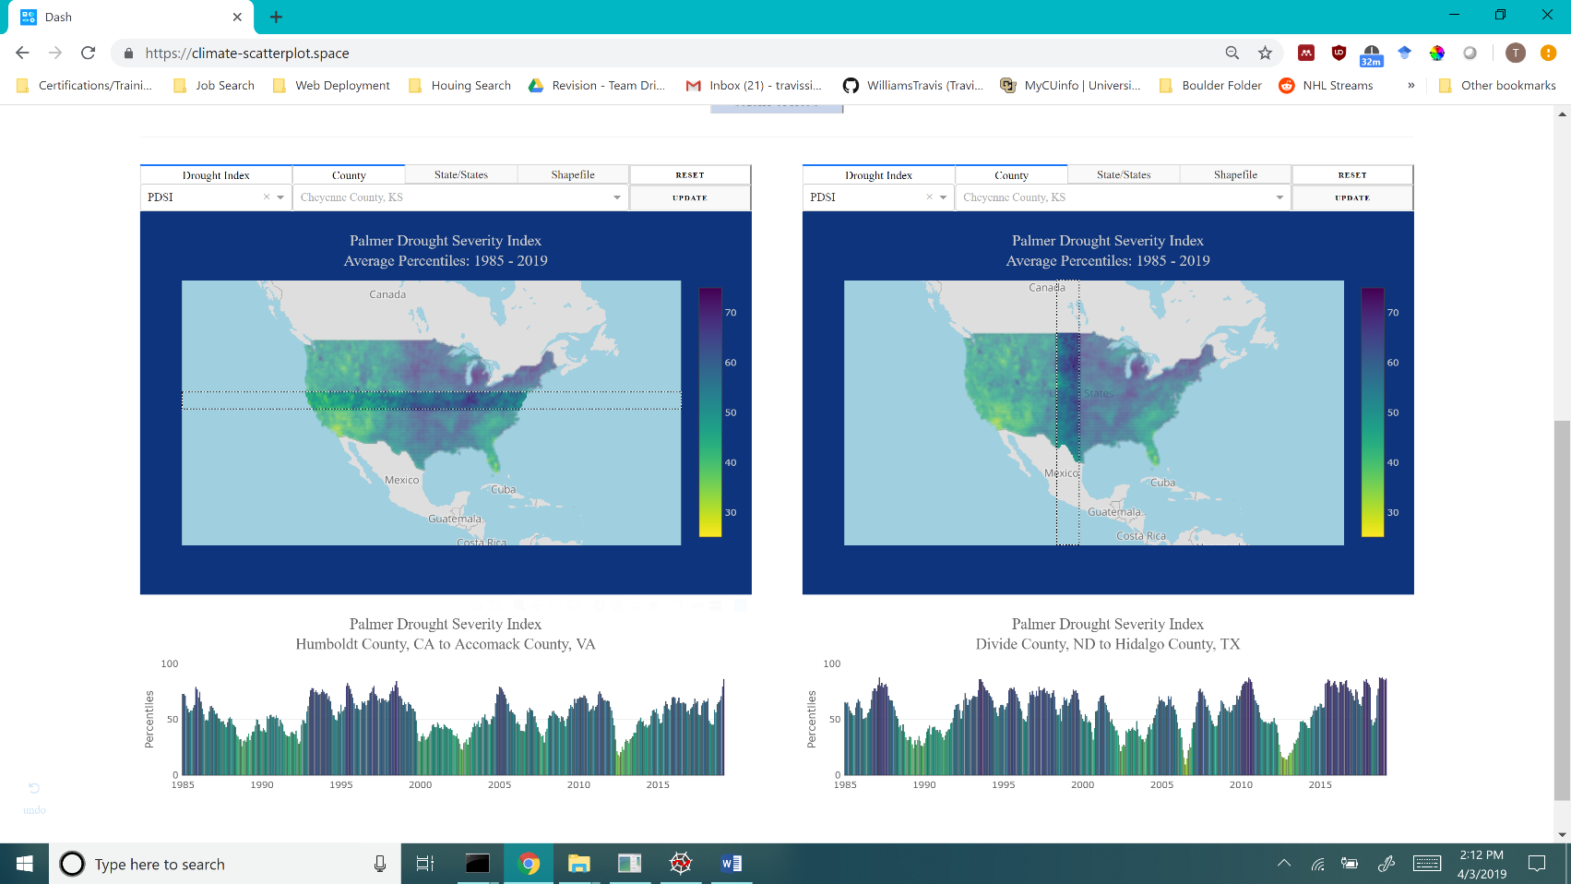

The resulting time series is highly manipulatable, as per the functionality of the [Plotly Dash](https://plot.ly/products/dash/) module by which the application is rendered. Using the toolbar at the top right of the graph, the user may change the y-scale, change the x-scale, zoom into any segment, and pan along either axis for an up-close view of the information. Double clicking on the graph resets the view and expands the range to the extent of the panel. The user may also use the select tool to highlight bar values above or below chosen y- or x-axis values (**Fig. 5**).

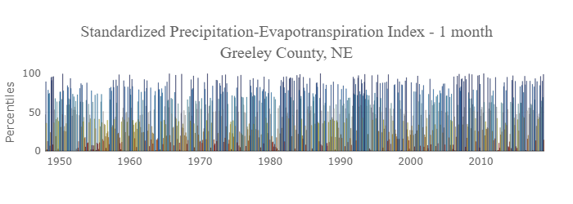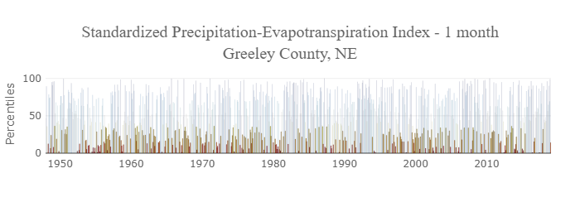

**Figure 5.** Time series values may be highlighted using the box selection tool, which is particularly useful for identifying patterns such as those buried within short-term index data.

## Identifying extreme events

Certain color scales combined with the minimum value (maximum for EDDI) option make it simple to find where and when extreme drought events (or anomalies) occurred. Because color schemes are relative to each map, these extreme values contrast highly with those around them, allowing the user to select a location, generate a time series, zoom into the general time period surrounding the event, and hover over the bar graph to find the exact month and year, as is demonstrated in **Figure 6**.

**Figure 6.** An example of using the “Minimum” value option to identify extreme events. In this case, the “RdYlGnBu” (Red, Yellow, Green, and Blue) color scale creates a field of relatively high (blue) values with pockets of low (orange/red) values where extreme events occurred at any point within the study period.

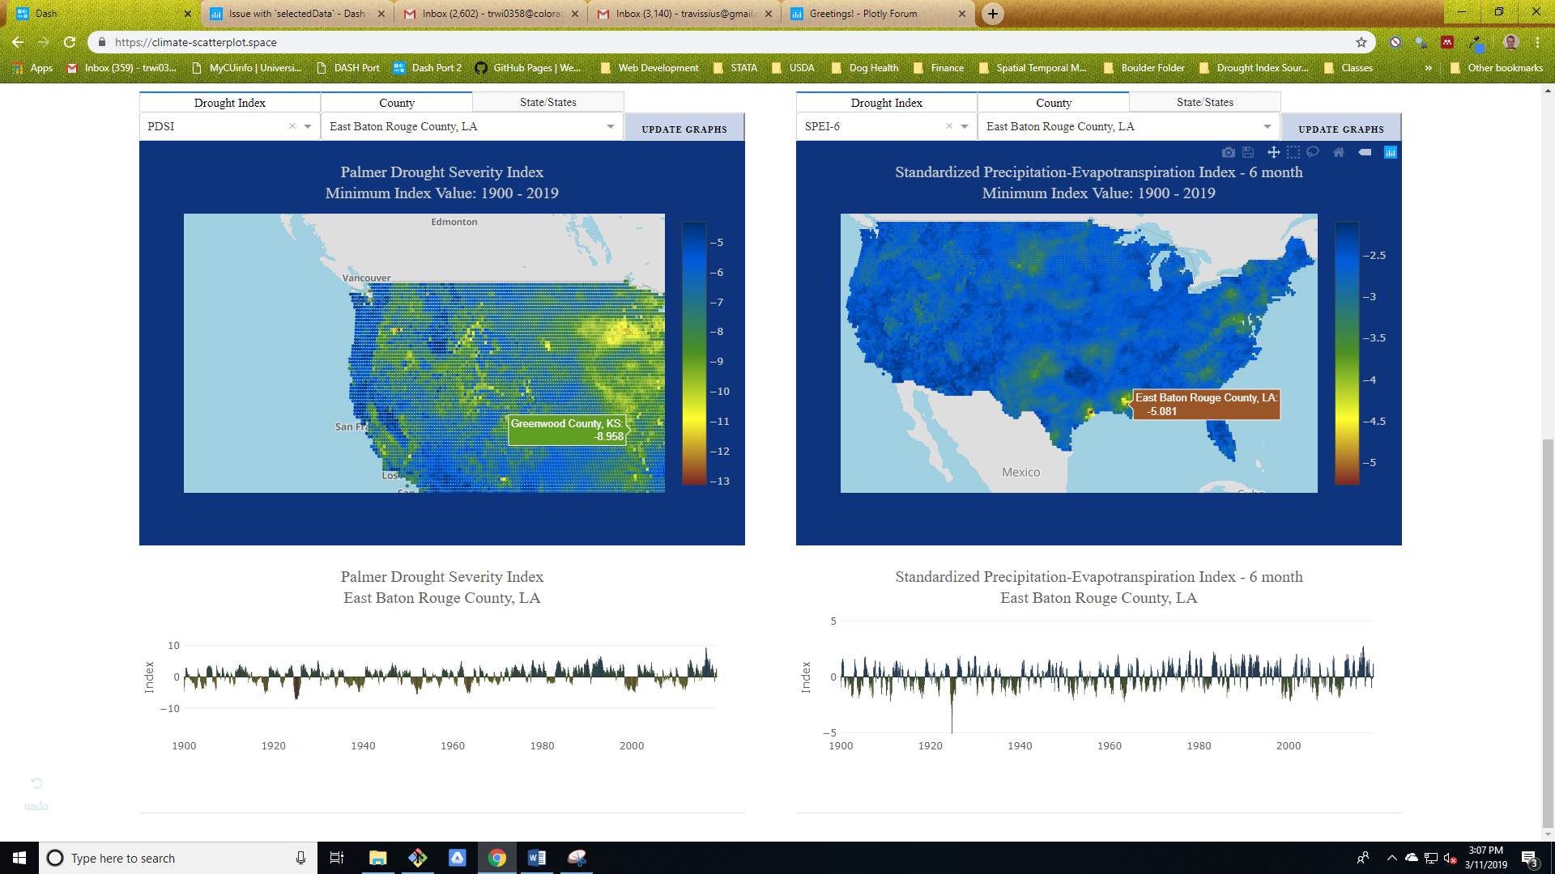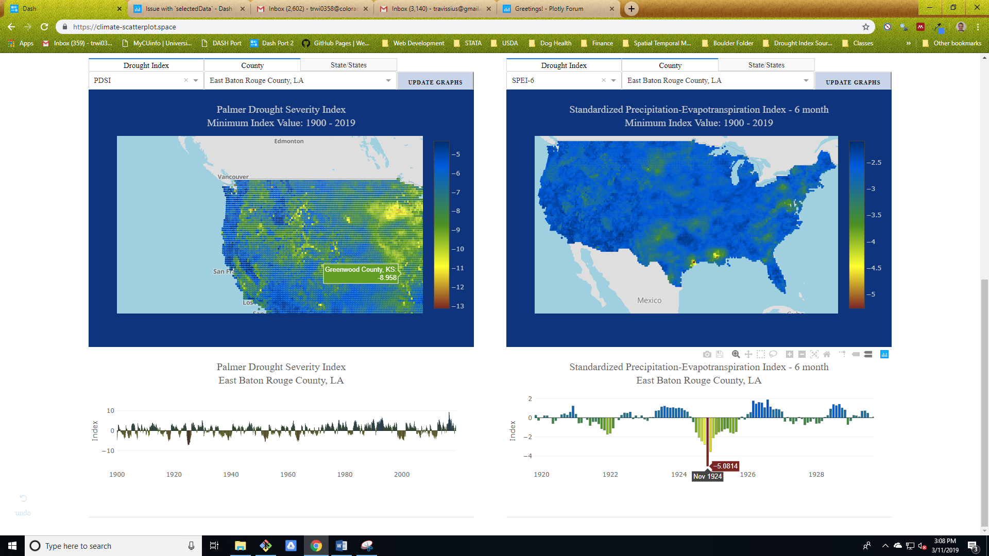

## The “Drought Severity Area” option

You may calculate the percentage of any selected area over a period of time that was in drought according to classifications found on the United States Drought Monitor (USDM) [data information page](https://droughtmonitor.unl.edu/AboutUSDM/AbouttheData.aspx). This is done in the background by projecting the selected coordinates to the North American Albers Equal Area Conic coordinate projection system, filtering the data for values within the specified categorical ranges, and calculating the percentage of grid cells within each category out of all . The information generated from this process is not the same as that shown in the USDM, but instead represents analogous estimations of drought severity according to similar products with longer histories. **Table 1** shows the categorical thresholds used for each index. The Palmer indices are each set according to that of the PDSI, and thresholds for the EDDI, SPEI, and SPI are set to that of the SPI (the original multi-scalar index). The percentages displayed are inclusive of overlapping categories such that an area in the “severe” drought category is also counted in the “moderate” and “dry” categories. Hovering over this graph will update monthly values of percent coverage for each category in a box at the bottom of the page.

**Figure 7.** The percentage of area in Montana, North Dakota, and South Dakota in each NDMC drought category according to the PDSI and Palmer Z Index from 1916 to 2019.

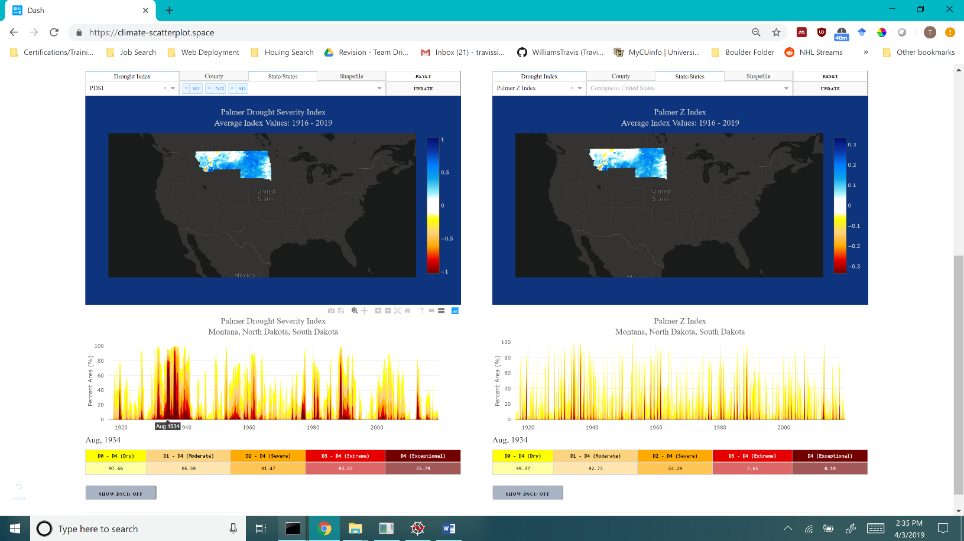

The Drought Severity Coverage Index (DSCI), which is described by the NDMC [here](https://droughtmonitor.unl.edu/AboutUSDM/AbouttheData/DSCI.aspx), is also available. The DSCI takes each drought category into account by weighting the percentage of area covered by each according to their respective levels of severity, as described below. This value is not calculated with inclusive categories.

DSCI = 1*(%D0) + 2*(%D2) + 3*(%D2) + 4*(%D3) + 5*(%D4)

|  |  |  |  |
| --- | --- | --- | --- |
| **Category** | **Description** | **Palmer Indices** | **SPI, SPEI, & EDDI** |
| D0 | Abnormally Dry | -1.0 to -2.0 | -0.5 to -0.8 |
| D1 | Moderate Drought | -2.0 to -3.0 | -0.8 to -1.3 |
| D2 | Severe Drought | -3.0 to -4.0 | -1.3 to -1.6 |
| D3 | Extreme Drought | -4.0 to -5.0 | -1.6 to -2.0 |
| D4 | Exceptional Drought | less than -5.0 | less than -2.0 |

**Table 1.** The drought severity categories for various indices used in the Drought Index Portal. Derived from the drought classifications used by the National Drought Mitigation Center.

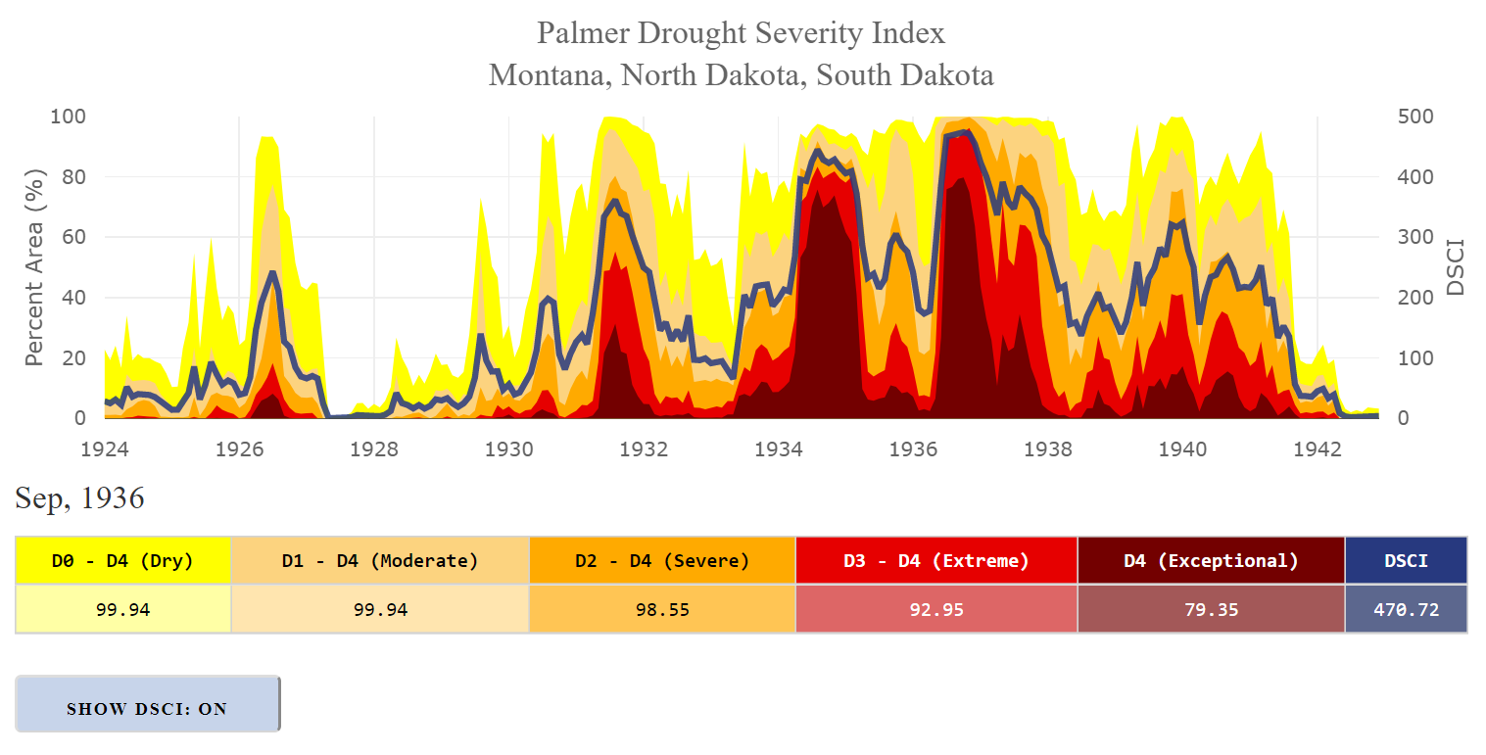

**Figure 1.** A line representing the Drought Severity Coverage Index (DSCI) may be toggled on and off to display a singular metric of drought severity by area.

## Downloading Information

There are currently three ways of downloading the information you generate with this application:

1. Hover over the top right corner of a graph and click the camera icon in the toolbar to download the image as a portable network graphic (.png) file.
2. Click the computer disk icon to edit the chart in Plotly’s chart studio. Visit this page for tutorials on how to use this service: [https://help.plot.ly/tutorials/#fundamentals](https://help.plot.ly/tutorials/%23fundamentals).
3. Click the “Download Time Series Data” link at the bottom of each time series graph to download a csv of the data underlying that graph.

# Access

This tool is available at https://droughtindexportal.colorado.edu/. It is in development and we appreciate your comments. Feel free to report any bugs or glitches and we will address them as soon as possible:

Travis Williams: travis.williams@colorado.edu

William Travis: william.travis@colorado.edu